Medal prediction of country using numerical data

Project Id: 26

Name : Tarun Purohit
Class Roll Number:71
University Roll Number : 2028880
Section and Group: P G2

Name : Shobhit Rawat
Class Roll Number: 66
University Roll Number : 2028851
Section and Group: P G2

Name : Gaurav Dubey
Class Roll Number: 44
University Roll Number : 2028719
Section and Group: P G2

- Problem Description

The Olympic Medal Prediction System is a machine learning based project developed to predict medal counts of countries using historical Olympic numerical data. The system analyzes athlete participation, country-wise performance, and year-wise statistics to estimate future medal counts accurately.

The project uses regression-based machine learning algorithms along with data preprocessing, exploratory data analysis (EDA), feature engineering, and visualization techniques to improve prediction accuracy. Missing values are handled, categorical variables are encoded, and important features are selected before model training.

The dataset contains features such as athlete information, country code (NOC), year, sport, event, medal records, height, weight, and participation statistics. The developed models are evaluated using regression performance metrics such as R² Score, MAE, MSE, and RMSE.

- Architecture

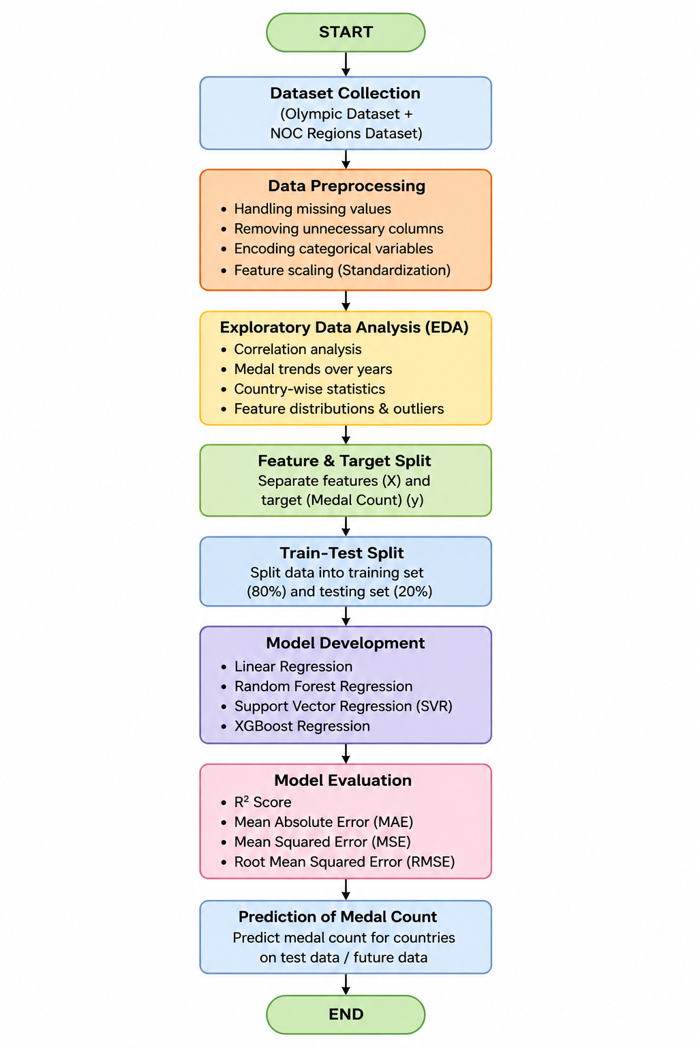

- Models Used(Applied/Planned)

Linear Regression: A supervised learning algorithm used for predicting numerical medal counts by establishing a linear relationship between features and target values.
Random Forest Regression: An ensemble learning algorithm that combines multiple decision trees to improve prediction accuracy and reduce overfitting.
Support Vector Regression (SVR): A regression technique that predicts continuous values while minimizing prediction error using support vectors.
XGBoost Regression: A boosting-based ensemble model that improves weak learners sequentially to produce highly accurate predictions.

- Evaluation metrics used

• R² Score: Measures how well the model explains the variance in medal count.
• Mean Absolute Error (MAE): Calculates the average absolute difference between predicted and actual medal counts.
• Mean Squared Error (MSE): Measures the average squared error in prediction.
• Root Mean Squared Error (RMSE): Represents the standard deviation of prediction errors.

5. Preliminary Results and Visualization

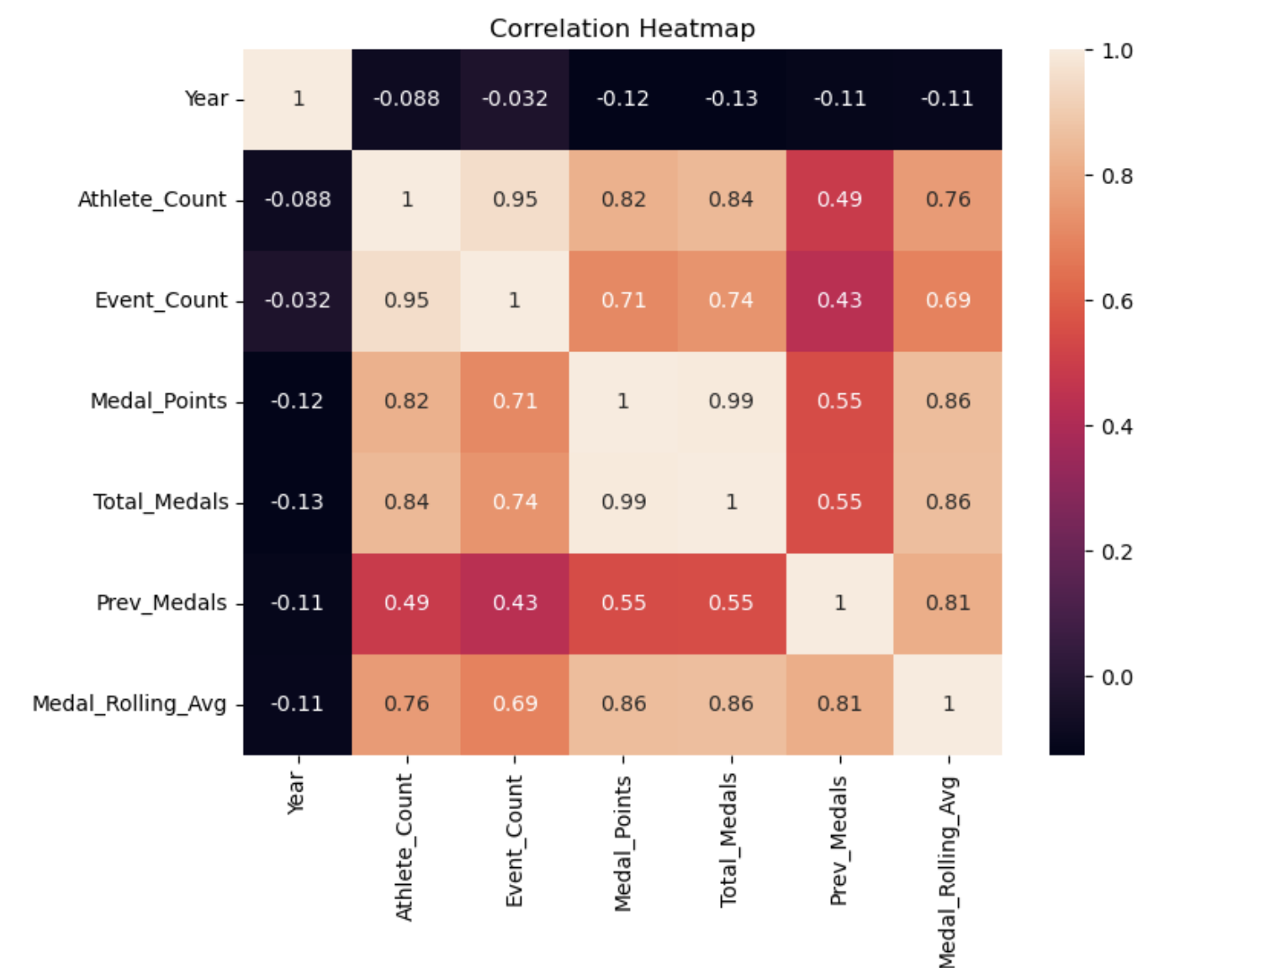

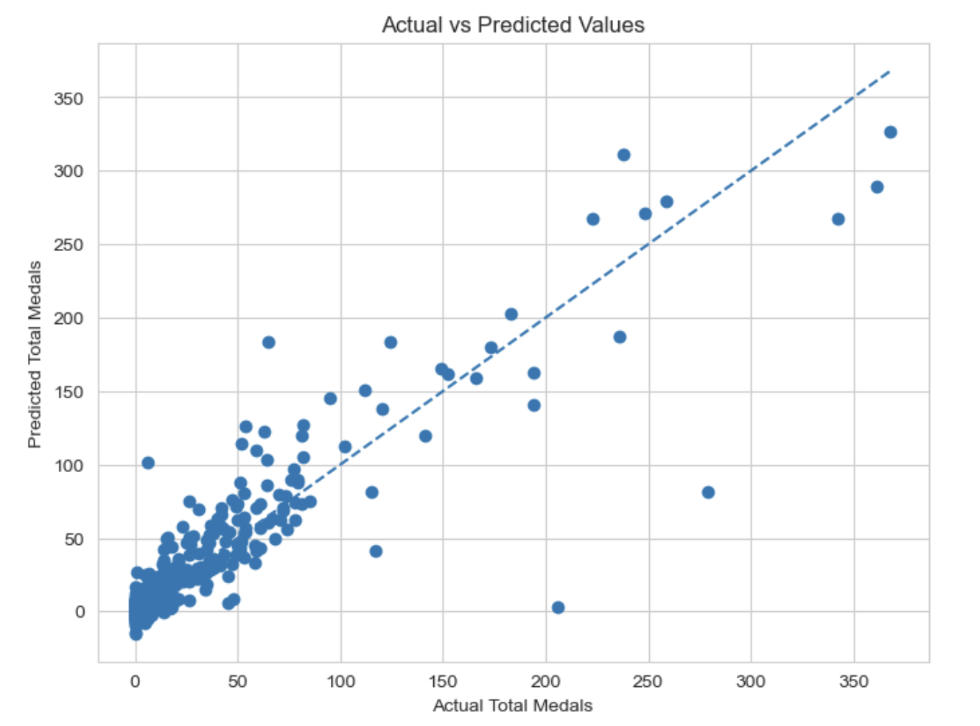

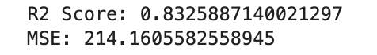


6. References:
Books:
- Let Us Python – Yashavant Kanetkar

Online Resources:
  - GeeksforGeeks – https://www.geeksforgeeks.org/
  - TutorialsPoint – https://www.tutorialspoint.com/cprogramming/index.htm
  - Stack Overflow – https://stackoverflow.com

